“Київський фаховий коледж зв’язку”

Циклова комісія Комп’ютерної інженерії

**ЗВІТ ПО ВИКОНАННЮ**

**WORK-CASE №5**

з дисципліни: «Операційні системи»

Виконавли студенти

групи РПЗ-03

Команда: Губенко Є.О.,

Заїка С.В. та Кресан Р.А.

Перевірив викладач

Сушанова В.С.

Київ 2022

**Хід роботи**

***Готував матеріал студент: Губенко Є.О***

1. **Розгляньте дані питання та дайте відповіді:**

* **При роботі з персональним комп’ютером дуже часто виникає необхідність підключати периферійне обладнання. На прикладі принтера та флешки опишіть який механізм має ОС Linux для роботи з ними.**

*Linux has a built-in Plug and Play mechanism that allows you to automatically recognize and connect new devices, such as printers and flash drives.*

*When you connect a new device to your computer, Linux automatically detects it and tries to install the necessary drivers and settings. If the necessary drivers are already present on the system, the device will be automatically installed and ready to use.*

*For example, if we connect a USB flash drive to a Linux computer, it is automatically detected by the system and appears on the desktop or in the file manager. We can open the flash drive and view its contents, copy and move files on it.*

*When you connect a printer, Linux will first check to see if the system has the necessary drivers for the device. If the drivers are installed, the printer will be automatically recognized and configured, and you can start printing.*

*If the drivers are missing, the system can offer to install the drivers from repositories or from the disk that came with the printer. After the drivers are installed, the printer is automatically configured and ready to use.*

*In general, Linux has powerful and convenient mechanisms for working with peripherals that allow users to easily and quickly connect and use new devices on their computer.*

***Готував матеріал студент: Заїка С. В.***

* **В чому суть операції монтування, для чого вона використовується та як?**

*Mounting is the process of connecting a file system to a specific directory in the operating system. After mounting, the file system becomes available for reading and writing to the corresponding processes running in the operating system.*

*The main purpose of mounting is to make the file system available to the operating system. This allows users to read and write data to the file system, as well as run programs that are located in this file system.*

*The mounting process can be performed automatically when the operating system boots, or it can be called manually by the user. To manually call the mount process, you can use the "mount" command in many operating systems.*

*When mounting a file system, you need to specify the mount point - this is the directory in the operating system to which the file system will be connected. For example, if we want to connect an external hard disk to the system, we can specify that its file system should be mounted to the /mnt/external_drive directory. After mounting, the external hard disk will be accessible through this directory.*

* **В чому різниця при роботі з периферією у ОС Linux та ОС Windows?**

*Linux and Windows have a slightly different approach to working with peripherals.*

*Linux typically has more extensive support for a variety of peripherals, such as printers, scanners, webcams, etc. Many peripherals can simply be plugged into the system and start working immediately, without the need to install additional drivers or programs. Linux also has a built-in mechanism for connecting devices via the USB bus.*

*Windows, on the other hand, has wider support for drivers from device manufacturers, which often allows for greater performance and more options when working with peripherals. However, some devices may require you to install drivers and software manually.*

*In addition, Windows has built-in tools such as Device Manager and Device Management Center that make it easy to install, configure, and remove peripherals. Linux also has its own device management tools, but they may require more technical expertise to use..*

***Готував матеріал студент: Кресан Руслан.***

1. **Підключіть до вашої віртуальної машини зі встановленою ОС Linux флешку та принтер (за можливості) та через графічний інтерфейс скопіюйте один файл з флешки на віртуальну машину та роздрукуйте його (такі ж самі дії повторіть, але з іншим файлом та через команди в терміналі).**

*For this assignment, I created a test image with the title of the work and the KFKZ logo, and downloaded it to my flash drive.*

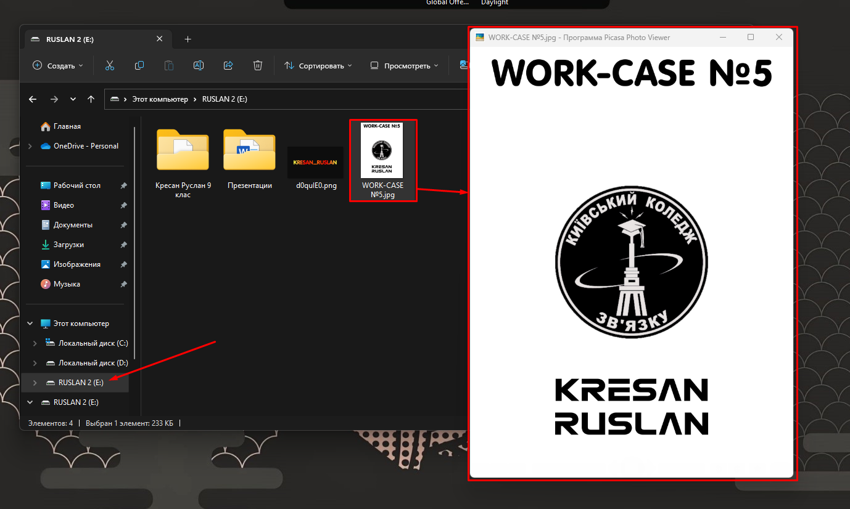

*Next, you need to connect the printer to the virtual machine. To do this, connect the printer cable to the computer. In the "Devices ->USB" tab, select the name of our printer.*

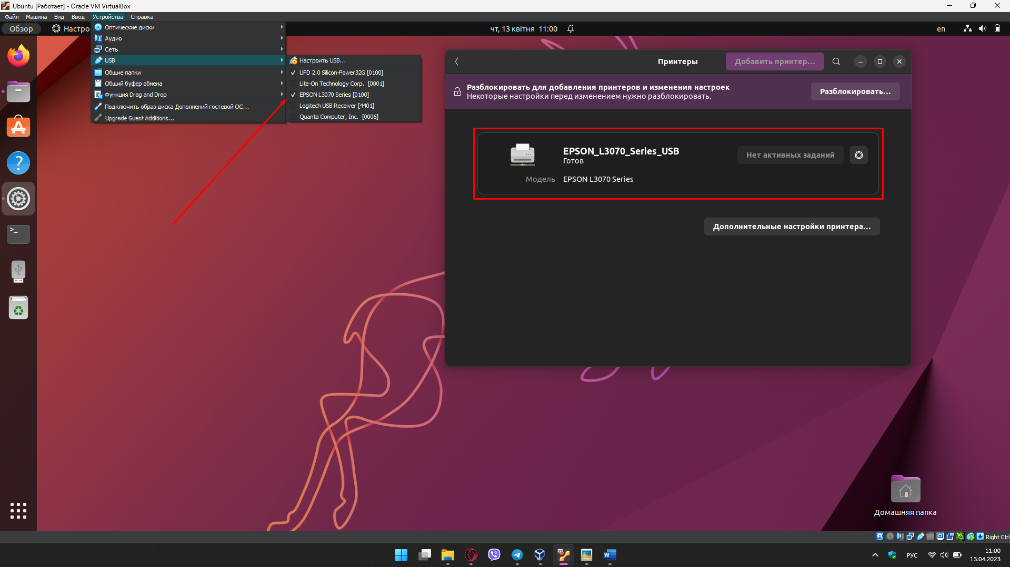

*Connect our flash drive in the same way.*

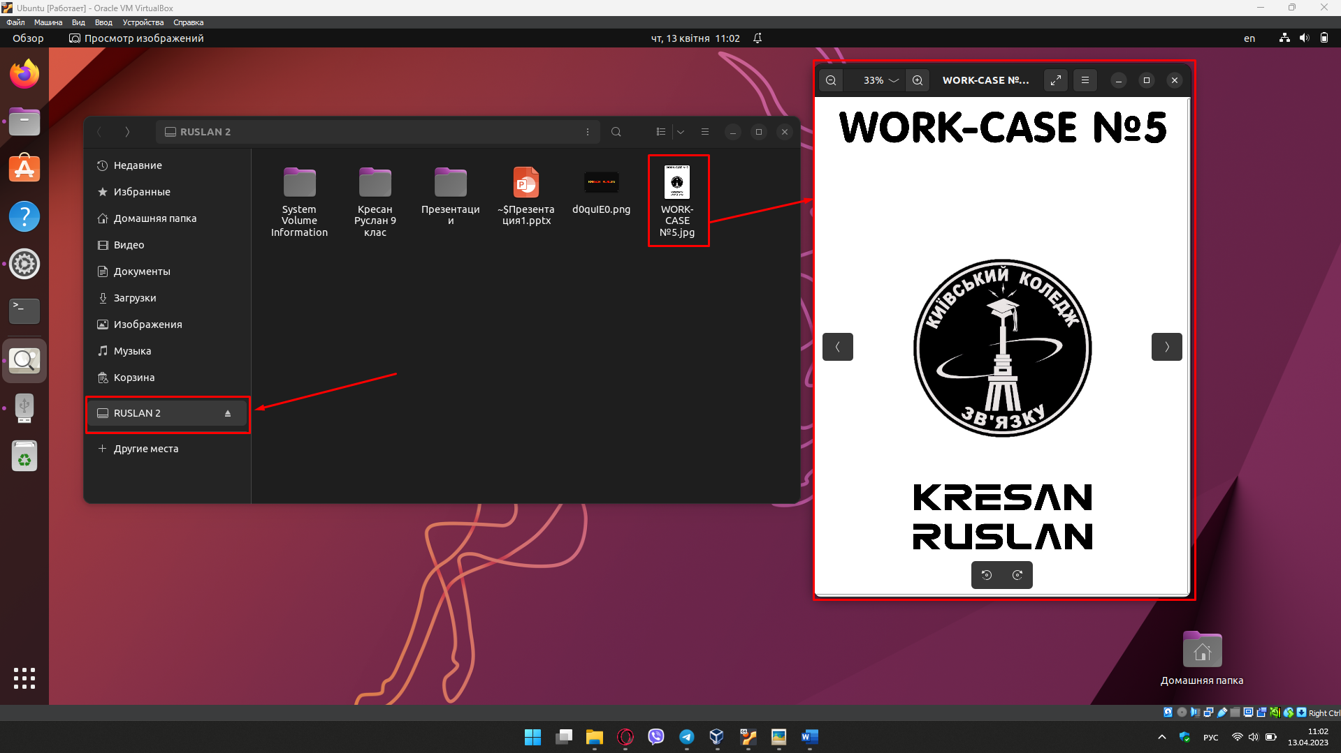

*When we have found the image we want to print, we press the menu button and select "Print…”.*

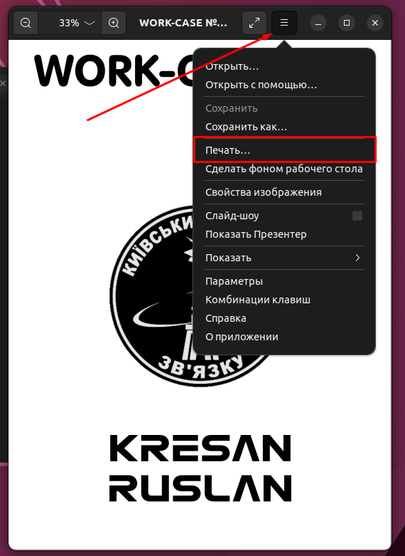

*After that, the print settings will open. Here you need to select the name of our printer and, if necessary, configure the print settings.*

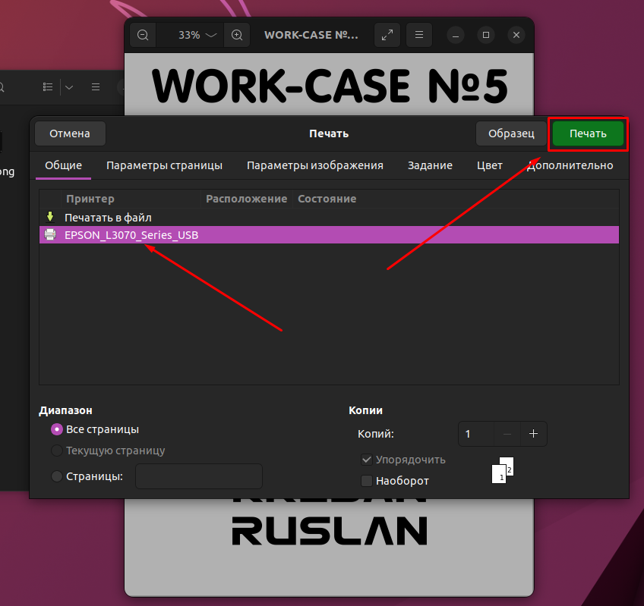

*After clicking on the "Print" button, the process of printing our image will begin.*

